Spring Boot, Angular, Mongo DB, Oracle

Compared to all the applications, FFA is the frontend, remaining are backend.

All the users can use remotely, and they can use multiple accents, connectivity tools, go for debrief, etc.

Tata sky, 6months free, after that charges, install and create request. Channels not getting, call to customer care, report to service center. First they will ask the error, try to troubleshoot it remotely. Otherwise come to home. Same thing in FFA.

Once hospitals buy these scanners, different countries have a contract for these months, CT Scanner, MRI Scanner, X-Ray. In that contract if they are facing an issue, they will call CC. CC will create a SR Service Request, There are experts, remote engineers who will pick requests. CT, MR.

If they are not able to fix it remotely, they will provide the analysis and dispatch to the field engineers.

eg: Noise is coming in scanner. Particular part needs to be replaced. Part needs to recommended by the remote engineer.

Completely replaces ISD, 4 years ago, it was decommissioned and on top of that, FFA was built.

FFA is the everything tool, there are no other tools.

From CRM, whatever SR is logged in CRM, it will get data into FFA.

CRS Applications:

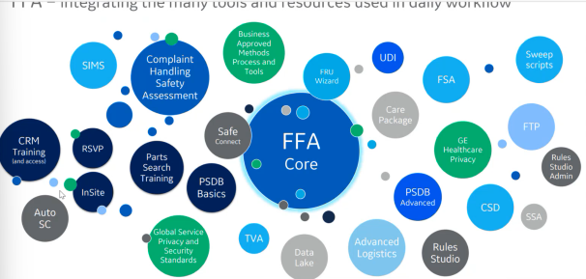

Benefits of FFA: providing info and tools when you need them, reducing the need to use many disparate tools to handle a single service event.

Service Journey: Customer reaches GE for service, SR is dispatched to either FE or RE. OLE inspects and dispatches care package to CSC(Customer Service Center). CSC orders only necessary parts based on OLE instructions

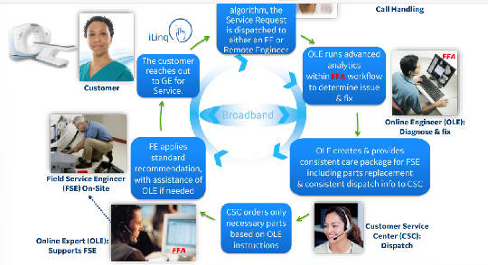

Closing of issues depends on CRMs, in some CRMs it is kept open for a few days, and then it closed after solved.

Technologies used to push data from CRM to FFA.

All the remote engineers cannot have same access, depends upon features, tools.

If RE doesn’t have full knowledge of the issue, he will take help of another RE with the help of a Support request ..

If RE is trying to analyze the issue, and the FFA tool is not responding, report to FFA support team, who will analyze RTS team

App is deployed in AWS, Services and UI Servers, Hino(On prem), Beijing-AWS

Rabbit MQ- Queue

We have all services, deploying all services in the ECS Cluster.

Most of the backend services connecting to Oracle.

Around 30 microservices for backend, each service around 8 EC2 instances, max 3 instances, same service.

Purpose of using Redish cache

All actions are captured in Greylog, no need to login to EC2 service.

4 data centers: us-can

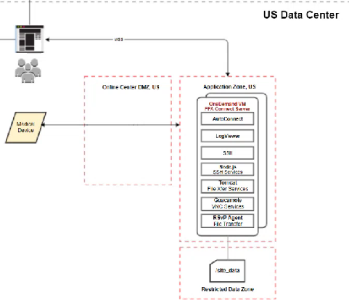

Europe(Support data+ uscan), Hino(Japan), Beijing, Moscow

Support service events globally, then we need access for all regions, add his profile, providing exceptions for all the countries. If a user wants access to other regions, he has to raise a ticket for the required country.

Two things- Remote(Remaining: Care Package) and Connectivity Related(Data Centers)

RTS will not support any of the service events, if Remote or Field engineers face any issue they would issue a report to RTS.

4 CRM: ServiceMax(eventual one), SEBEL America, SEBEL International(India, China, Australia, New Zealand), MUST(Europe Countries, half, remaining: ServiceMax, no UI, not user-friendly, mainframe based)

Standby(Green) and Production(Blue):

Two URLs: ffa.gehealthcare.com: Internet URL, Field Engineers(Check CP), Restricted(Connectivity Tools)

ffa.health.ge.com: Intranet URL, GE Network

Databases: FFA Database(FFA uses more), MAC Data, MDR(both common, managed by Rule Studio), GSCC(FFA uses more), HCA, UM

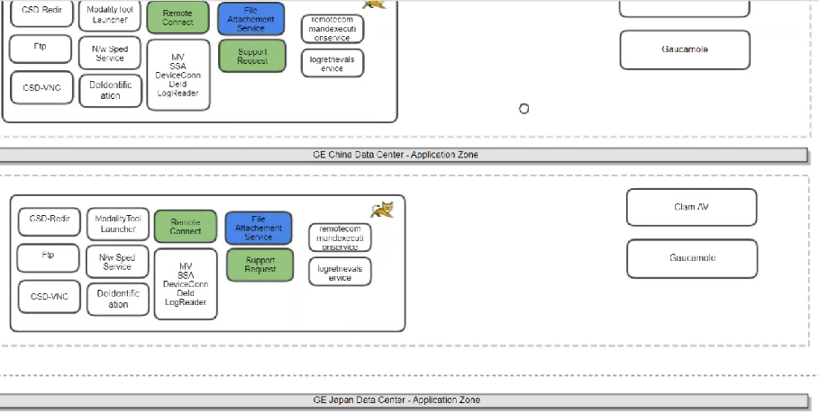

Mongo db- access related

* Raise FFA request : **FFA for the Field Engineer, Protecting Customer Data Is Everyone's Business.. Protecting Customer Data Is Everyone's Business..: Protecting Customer Data Is Everyone's Business.. Protecting Customer Data Is Everyone's Business..: Protecting Customer Data Is Everyone's Business..: FFA for the Field Engineer, Protecting Customer Data Is Everyone's Business..: MV REMOTE DIAGNOSTIC SYSTEM (RDS) BASIC TRAINING, MV REMOTE CONNECTIVITY BASIC TRAINING..: MV REMOTE DIAGNOSTIC SYSTEM (RDS) BASIC TRAINING, MV REMOTE CONNECTIVITY BASIC TRAINING.. The entitlement "Field Force Automation (FFA)-India & South Asia-Role-Application Specialist" requires the following outstanding training(s) to be completed: FFA for the Applications Specialist, FFA for the Field Engineer, Protecting Customer Data Is Everyone's Business.. The entitlement "Field Force Automation (FFA)-India & South Asia-Role-Modality Engineer (for SPRSnap access only)" requires the following outstanding training(s) to be completed: Protecting Customer Data Is Everyone's Business.. The entitlement "Field Force Automation (FFA)-India & South Asia-Role-Checkout Admin (for DI InSite1 checkout only)" requires the following outstanding training(s) to be completed: Protecting Customer Data Is Everyone's Business.. The entitlement "Field Force Automation (FFA)-India & South Asia-Role-MV FE" requires the following outstanding training(s) to be completed: MV REMOTE DIAGNOSTIC SYSTEM (RDS) BASIC TRAINING, MV REMOTE CONNECTIVITY BASIC TRAINING.. The entitlement "Field Force Automation (FFA)-India & South Asia-Role-RTE" requires the following outstanding training(s) to be completed: Protecting Customer Data Is Everyone's Business, FFA for the Remote Engineer.**

Trainings, oneidm.ge.com Search CRS

InsitePlus

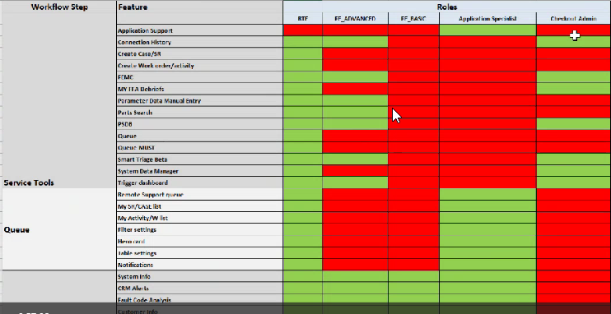

Swagger(non-prod), Postman(production)

In FFA, we have 4 environments: Development(dev-ffa.health.ge.com)->, Staging(Testing/QA, stg-ffa.health.ge.com), Standby(Pre-prod, Push the changes, QA and RTS will test, ffa.health.ge.com:80), Production(after everything works fine, ffa.health.ge.com).

FFA is a JXP based application.

FFA: Intranet: ffa.health.ge.com (MyApps, GE LAN, F5, BlueSSO, Global Protect, these are ways you can connect to GE Network) and Internet: ffa.gehealthcare.com(Queue, Connectivity tools, etc will not display) URLs.

ffa.health.ge.com

If you do not have any roles, it will display not valid user.

Start Workflow: Opens another login page

Service Tools:

Admin:

Profile:

Unit: Not used nowadays (Europe or other users)

Any role if you want to remove you can remove from CRS.

Phone Client Version: Avaya

Launch with SysID/Serial No. or (SR ID and Country of System)

Otherwise go to CRM and click on FFA link, Direct launch

Other Applications: Go to mytech.ge.com

Go to either administration request or incident creation

Incident for PSDB: Search

If anu user faces any issue for FFA and needs to create a incident, no need to go to mytech and create an incident, instead directly give feedback and submit in the specific application and submit like in FFA.

FFA:

Advanced search: RSVP Systems: Country, Modality: MR, CRM Number: M1

Before launching we can see whether the device is connected or not.

(If you do not have test systems, don’t take customer systems.)

Search returned more than max limit of 300 assets. Check the max limit.

Modality: MR, CT, XR(X-Ray), UL(Ultrasound), NM, DCAR, MV(Multivendor), PET, LCS

For every modality we can have multiple model types.

For Rsvp devices only we use the Device Look-Up:

Connection from connectivity server to device, offline if not connection. If it is polling

Offline: No connection

Online: Server made a connection with device but no polling/response

Connected: With polling

Only for RSVP Systems

In device lookup, no check up for ffa

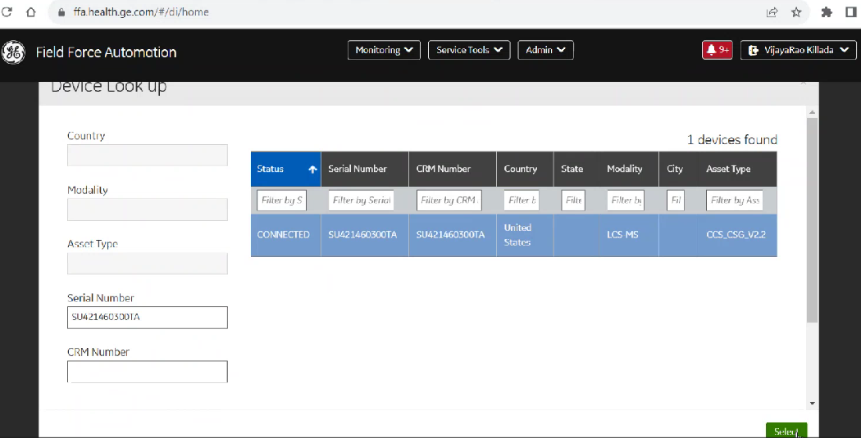

Difference between Modality and Asset Type:

Eg: In CT modality, Different model/asset types

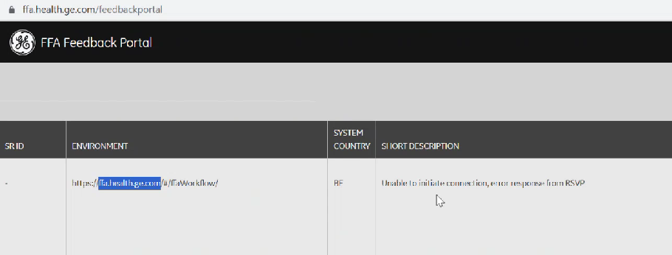Ffa, Admin, Feedback portal, See incidents created, Max last 15 days

95% of the incidents you get for production, 5% for staging environment, No incidents for development.

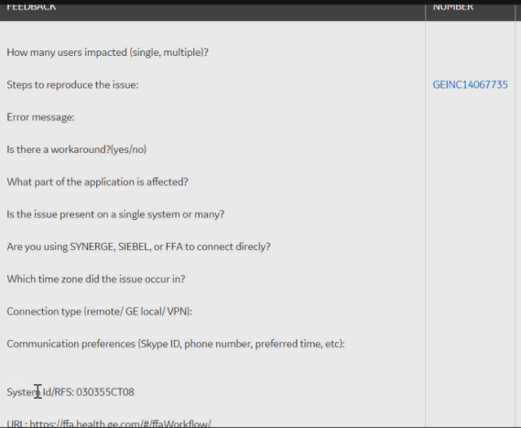

Maintaining Session Id, Multiple Microservices.

Tickets in geit.service-now.com

3 kinds of systems:

Insite1---Checkout, RSVP—Axeda Systems(Register the device), Questra Systems(Register the device)

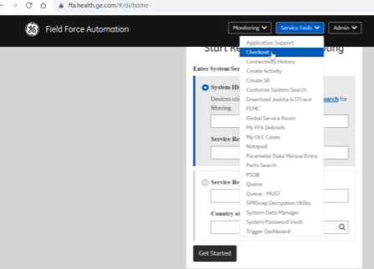When medical devices are bought device details have to be updated or registered in the ge.

We take system related data and maintain it in our database.

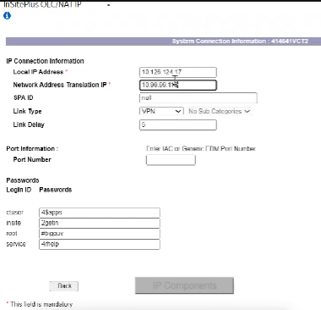

Steps to Checkout in Insite

System related information we can get from CRM, Connectivity related information we can get from Insite

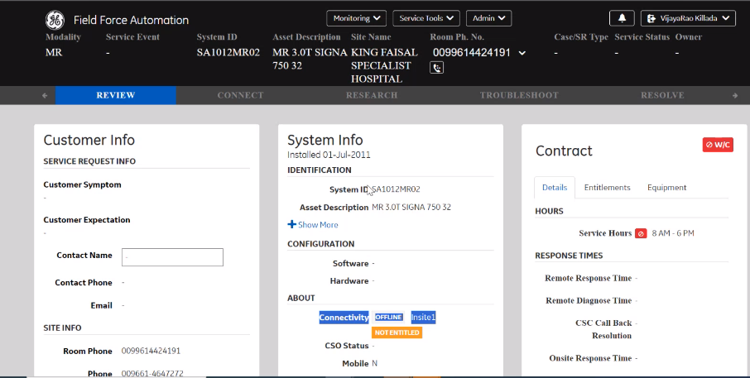Staging Environment:

Generation Ascending: Insite 1, Questra, RSVP or Axeda Agent, PSDB

AutoSC: Data is retrieved through a script or command.

Push data through AutoSC also based on a specific interval and stored on Datalake or Database.

None of the applications own the scripts.

For accessing FFA feedback portal user should have the role of admin.

Portal shows the last 15 days record only.

Using the thread we find the exact issue.

For frontend microservice we use session id to debug, and for backend microservice we use thread to debug the incident.

50% applications: FFA, 50% remaining applications

We can find the system id from FFA, from System ID we can get the thread id which is used for finding the logs.

When you are launching the workflow in FFA application, if you want to check the logs, if something has failed, you can go to the logs of that particular service, and you can check with system id/thread id, i.e. you can search with System id, find the thread, from the thread you can find the logs.

Eg: If workflow is not launching, check the service logs. For that what needs to be done is, go to that particular EC2 instance, go to that particular docker service, there with the system id, we would find the thread id, and with the thread id, we can find what is happening or why it is not launched.

Note: We have to search which particular EC2 instances this particular service is running. Go to docker container and check the logs.

CRM--- HCA(System related Information)-------Data source, We take data and store it into database HCA. CRM provides system related information not anything related to Connectivity. Eg: System, Hospital, Address of the hospital, Contact No’s, Field Engineers etc. Using loaders we get data and store into database HCA.

Insite—--checkout----GSCC(Connectivity related information)---- User provides all connectivity information. LAN IP, Address of the system, Passwords we can use. Server will check that when we are connecting, all the protocols are accessible or not. Through checkout, we check that all the ip addresses are visible from our servers or not, all the protocols are accessible or not.

RSVP----Axeda----- It is not a part of the connectivity server, it is a type of the device.

Purchase, install, register with crm

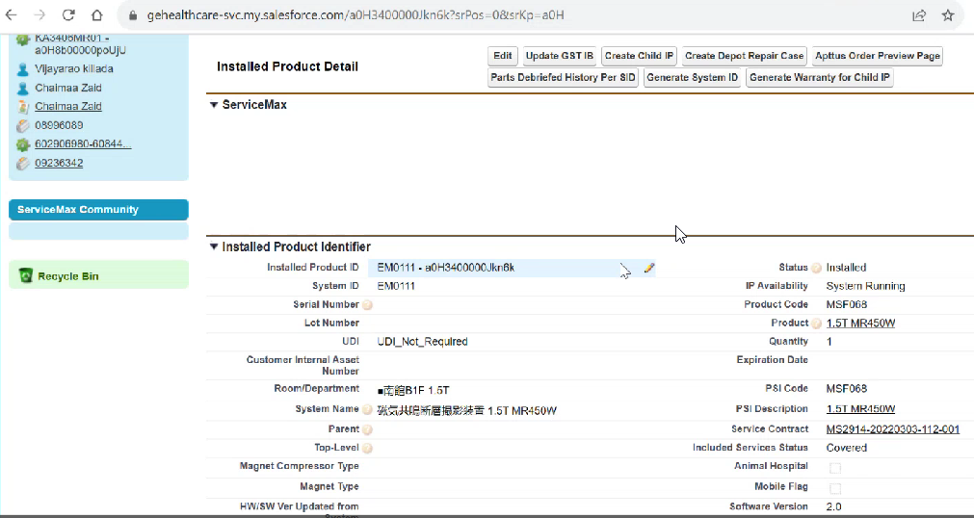

MUST----RFS----Support Request(Optional)

FFA DB

SMAX---Case-----Word orders

Siebel Intl----SR-------Activity

Siebel AM----SR

2 Queues:

MUST Queue----MUST

Queue(Global Queue)-----SMAX+ Siebel Intl

RE can create SR, Customer to Service Center who creates SR, From device end SR can be created.

One RFS can have multiple support requests. If a RE thinks that the issue is very complex, he creates a SR again like this. One RFS is considered to be closed, if all the associated Support requests are closed.

SRs in practical, rarely used.

In SMAX, 1 case multiple WO.

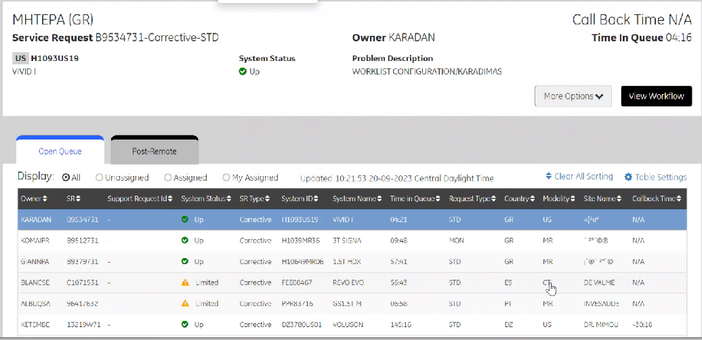

Displays Jobs

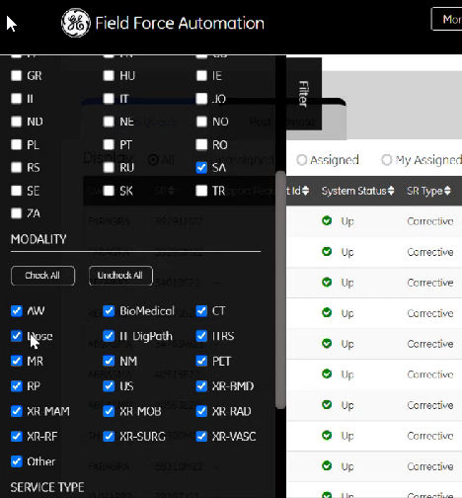

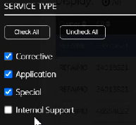

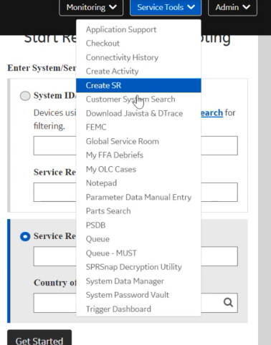

Insite1- VPN

FFA Queue

Callback Time: Not more than 15 mins

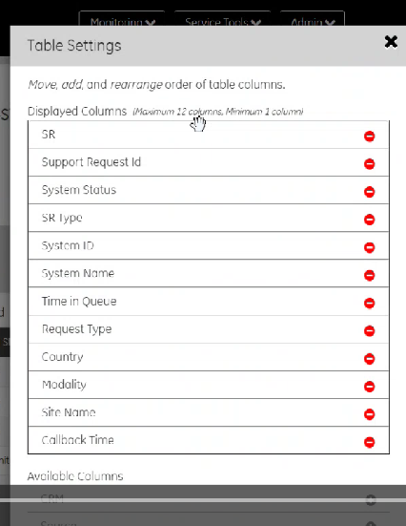

If any time if updated time is not updating means, there is an issue with CRM.

List of RFS

Top is the hero card, any rfc we pick we see the data in the hero card.

When RE publishes the Care package, the open rfs will be removed from the queue.

Mainframe id, Profile Id: MUST users must have to publish CARE package.

Don’t have: Contact FASTeam

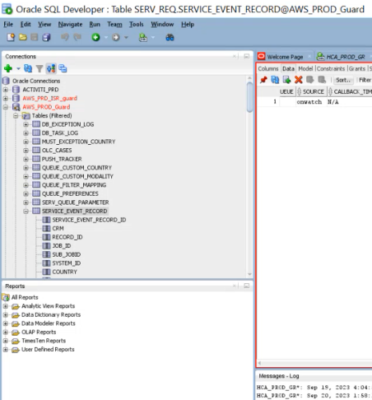



RFS created and updated time.

Don’t confuse support(create from rfs) and service request(create from system id).

View workflow---Launch workflow

Only FFA DB is maintained.

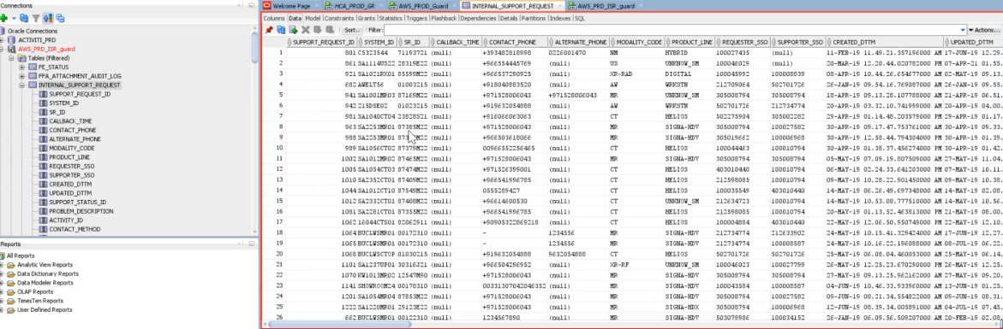HCA and all aren’t maintained currently.

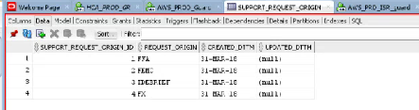

Types of Support request origin, where they are created.

Support Request Status

In Service Actions, we will see something like Request handover and request follow up.

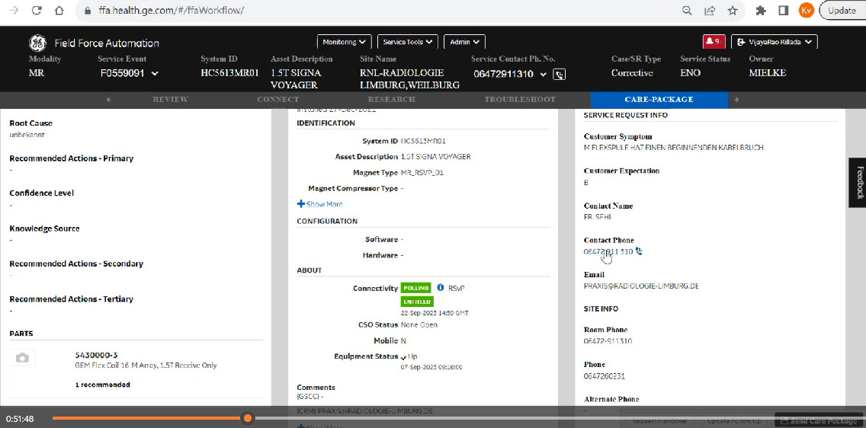

Follow up: Issue is resolved to some extent, follow up is required to check working or not after some time intervals.

Handover: Handover it to some other RE.

R: Follow Up

N: Handover

In post remote: either follow up or handover.

Some crms: fix, when fix, no further action, does not come to post remote.

Not fixed completely even after publishing care package, plans follow up or handover.

MUST queue. RFS create.

Different ways:

CSC

FFA(MUST/Siebel Intl)

iLinq

Onwatch/RS

iCenter

Mygehealthcare

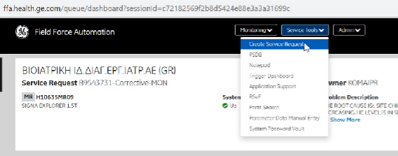

Service Request create, It is nothing but RFS.

Job is nothing but a RFS or SR.

Queue-MUST in service tools

SR is created and assigned

Same SR you can find in queue.

Any profile related changes you have to log out and log in, then only you can see the updated profile.

Create support request- MUST appears after changing user profile to EU- Spain

Create Support Request- MUST



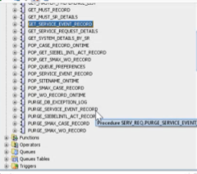

Global Queue: Name is Queue

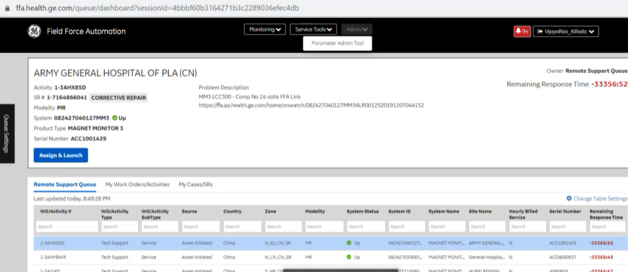

SMAX(Topic -1 or -2) + Siebel Intl (Kafka topic)

70% of the users launch from crm only not from Siebel intl.

China uses FFA mainly for connectivity tools, they use CRM for publishing care packages.

For MUST they do not have any option since it is a mainframe they have to depend on FFA, for other CRMs they can do everything without FFA except analyze whatever they have integrated.

To close a case in SMAX we have to close all the work orders.

Troubleshoot the issue: FFA is required, else

CRM

MUST users are 100% dependent on FFA, other CRMs are not like that.

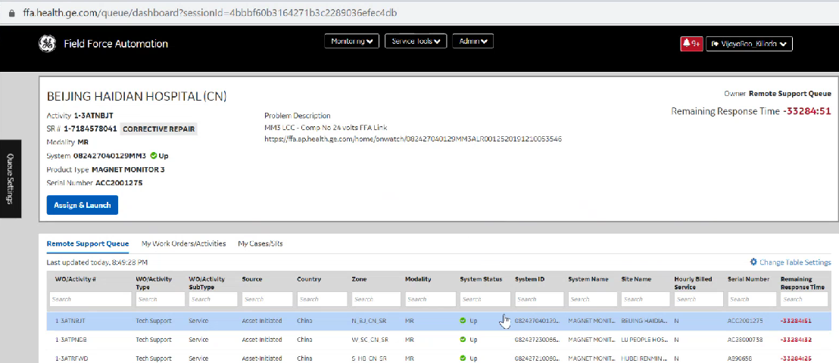

Work orders always start with WO, other wise activity

Different tables for Siebel Intl and SMAX

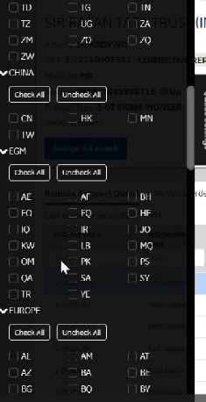

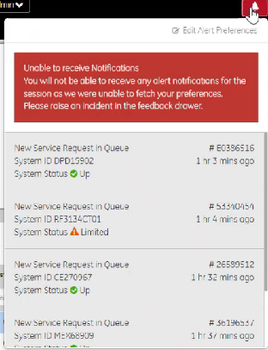

These alerts are only for MUST CRM, not for SMAX or Siebel Intl

Siebel uses Kakfka and SMAX uses Topic to publish data. Kafka is not designed to handle multiple requests at the same time. FFA consumes that and stores it in database.

In FFA major areas: Connectivity tools, Publishing

If you want to assign to someone, you have to do it from CRM.

11- 23:51